Auction Donation Form
For committee use only

Item # _____
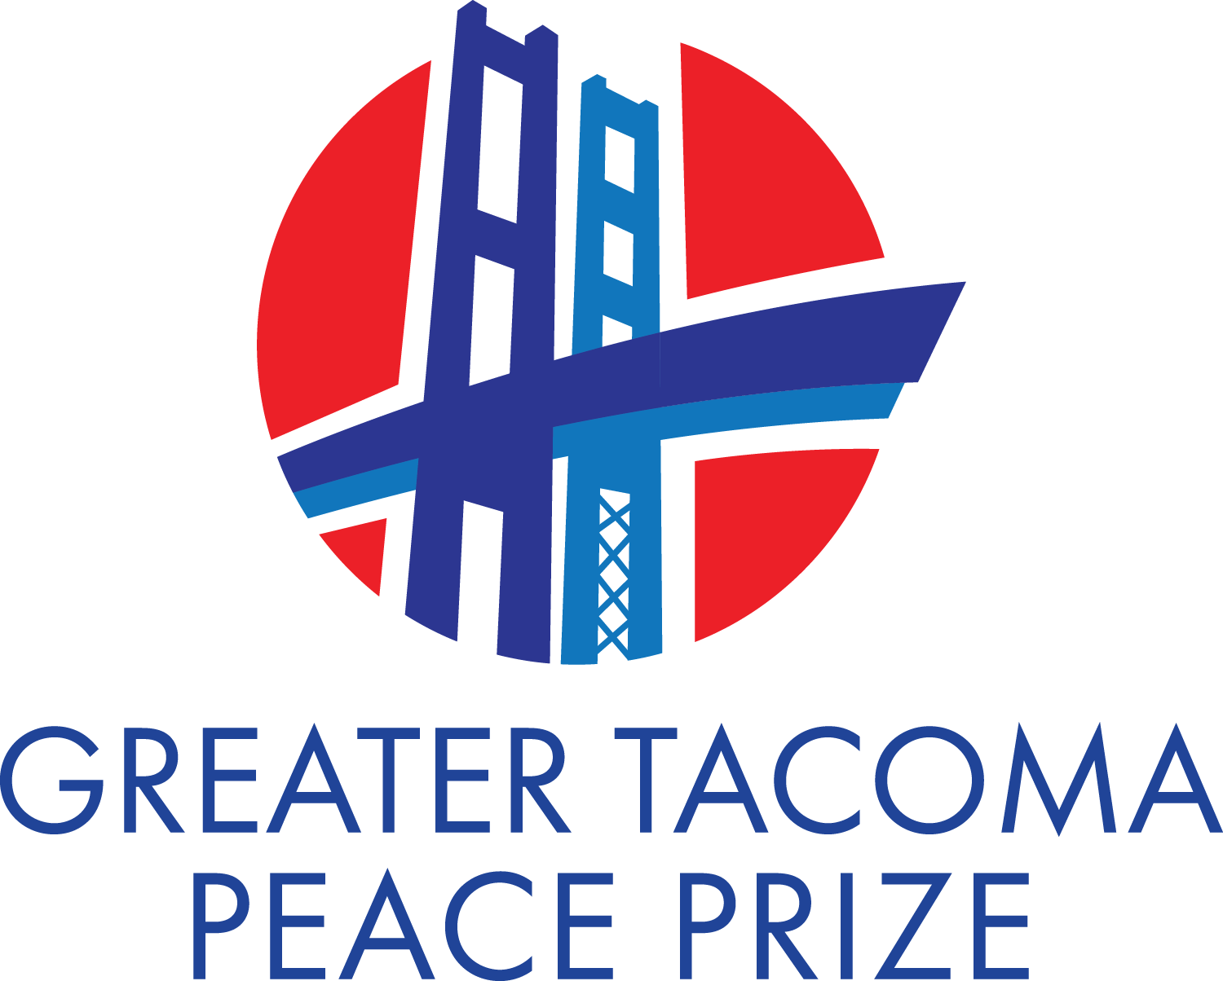
Greater Tacoma Peace Prize
Laureate Recognition Banquet
September 15, 2022
Email:
committee@tacomapeaceprize.org

Name of Donor
Check here if donor wishes to remain anonymous.
Address
Phone Email

Donated product(s) or service
Please describe completely, giving size, colors, etc. If donating more than one item, please list, describe, and give the fair market value of each item. Include any restrictions, such as expiration dates, travel dates, minimum bid, etc.

DESCRIPTION OF ITEM(S) FAIR MARKET VALUE

FOR ADDITIONAL ITEMS, USE OTHER SIDE…

Check all that apply
Donor will provide Gift Certificate Auction Committee will provide display
Auction Committee will create Gift Certificate Donor will provide display
Arrange for item(s) to be picked up or delivered

Please return this form and item(s) BY MONDAY, SEPTEMBER 5, to:

Lisa Ottoson (253-906-4323) OR ________________
For committee use only
Name of Procurer
Phone Email

